|  |  |
| --- | --- |
| **Sprint 4** | **Converting data received from cloud as voice using IBM Text to Speech service** |
| **Team ID** | **PNT2022TMID50604** |
| **Project Name** | **Project–Personal Assistance for Seniors Who Are Self-Reliant** |

# INSTALLATION OF WATSON VERSION - Code :

Pip install – upgrade “ ibm – Watson > =6.1.0”

# Result :

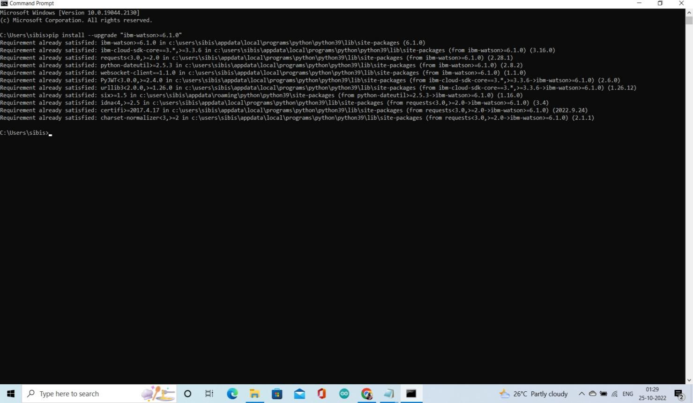

1. **COPYING CREDENTIALS FOR A PIAND URL :**

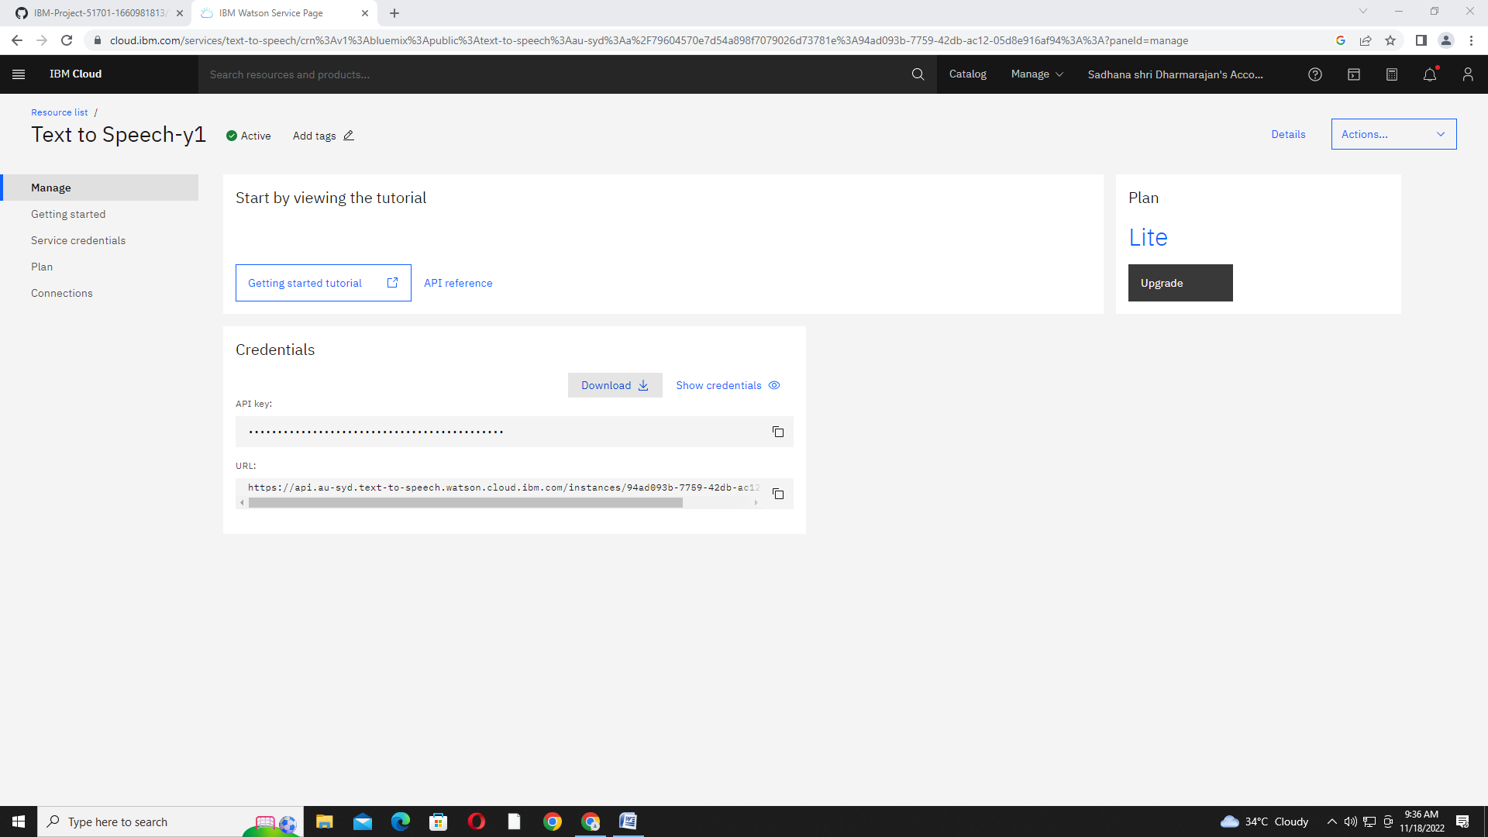

# 2)PROGRAM FOR ACCESSING APIs OFTTS SERVICE :

fromibm_watsonimportTextToSpeechV1

fromibm _ cloud_sdk_core.authenticatorsimportIAMAuthenticator

authenticator = IAMAuthenticator('1SuMpBioLx9PuvKX-wnvMh3Z3lQbUKcXZErWleXdmY9j')

text_to_speech = TextToSpeechV1(authenticator=authenticator

)

text_to_speech.set_service_url('https://api.au-syd.text-to-speech.watson.cloud.ibm.com/instances/d3e4f1ee-ccf4-4e79-a3bf-71cdb9fdf9e8')

with open('hello_world.wav', 'wb') as audio_file:audio_file.write(

text_to_speech.synthesize('TakeCrocin Now',

voice='en-US_AllisonV3Voice',accept='audio/wav'

).get_result().content)

# Execution and Run :

